**Year 7 Humanities**

**Geography: Water in the World**

**Encyclopedia available on library website**

[***World Book***](https://www.worldbookonline.com/?uid=avila&pwd=student)

Access World Book via the Avila Library website (Go to ‘Online Resources’ - ‘World Book online’).

Go to ‘Student’ to access student website. These articles are available on the World Book website:

* The Ganges River
* The Nile River
* The Tigris River
* The Euphrates River
* The Indus River
* The Mekong River

**Websites available on library website**

Use the following websites to search your topic. Each site has been hyperlinked for easy access.

[***Weblinks***](https://www.weblinksresearch.com/login/weblinks-online/)

An educational search engine that collates suitable websites for secondary school students.

Username: avila

Password: charles

[***ABC Splash***](http://education.abc.net.au/home#!/resources)

**Other Websites**

**The Ganges River**

[World Wildlife Fund](https://www.wwf.org.uk/where-we-work/ganges)

[The race to save the river Ganges](https://graphics.reuters.com/INDIA-RIVER/010081TW39P/index.html)

[The Ganges: River of life, religion and pollution](https://geographical.co.uk/culture/the-ganges-river-of-life-religion-and-pollution)

**The Nile River**

[Nile River Facts](https://www.natgeokids.com/au/discover/geography/physical-geography/nile-river-facts/)

[Nile River](https://www.newworldencyclopedia.org/entry/Nile_River)

[Journey to Egypt – Nile River](https://www.journeytoegypt.com/en/blog/nile-river)

[Geography and the Nile River](https://www.ducksters.com/history/ancient_egypt/geography_nile_river.php)

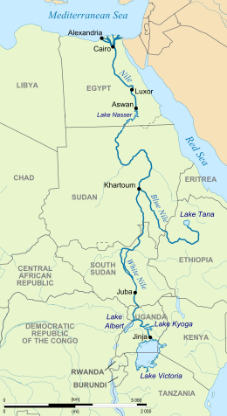

**The Tigris River**

[All about Turkey – Tigris River](https://www.allaboutturkey.com/tigris.html)

[Tigris River for Kids](https://easyscienceforkids.com/tigris-river/)

[Tigris River](https://education.nationalgeographic.org/resource/tigris-river)

**The Euphrates River**

[Euphrates River facts](https://easyscienceforkids.com/euphrates-river/)

[Euphrates Facts for kids](https://kids.kiddle.co/Euphrates)

[World Atlas – Euphrates River](https://www.worldatlas.com/rivers/euphrates-river.html)

**The Indus River**

[Indus River facts for kids](https://kids.kiddle.co/Indus_River)

[Indus River](https://easyscienceforkids.com/indus-river/)

**The Mekong River**

[Mekong River Facts for kids](https://kids.kiddle.co/Mekong_River)

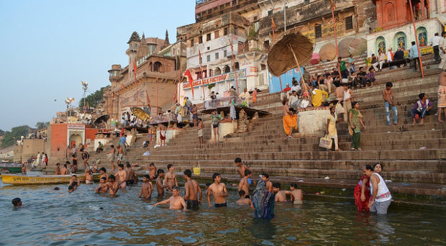[Fun facts about Mekong River](https://easyscienceforkids.com/mekong-river/)